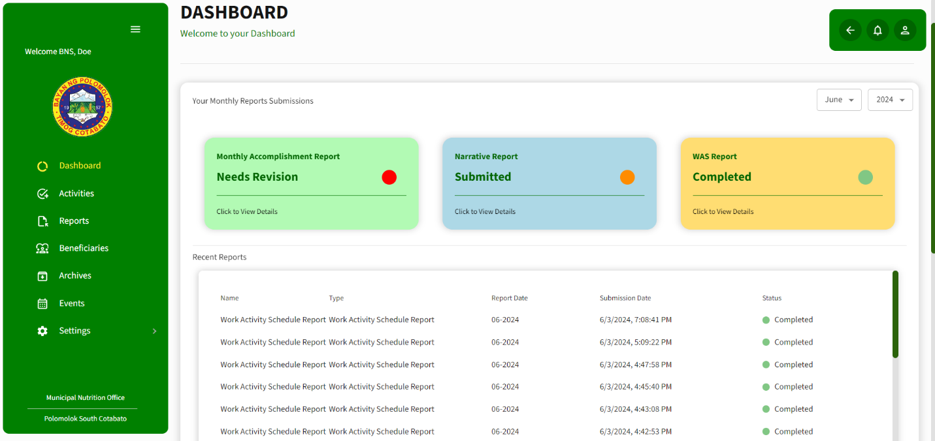DASHBOARD BNS REPORTS

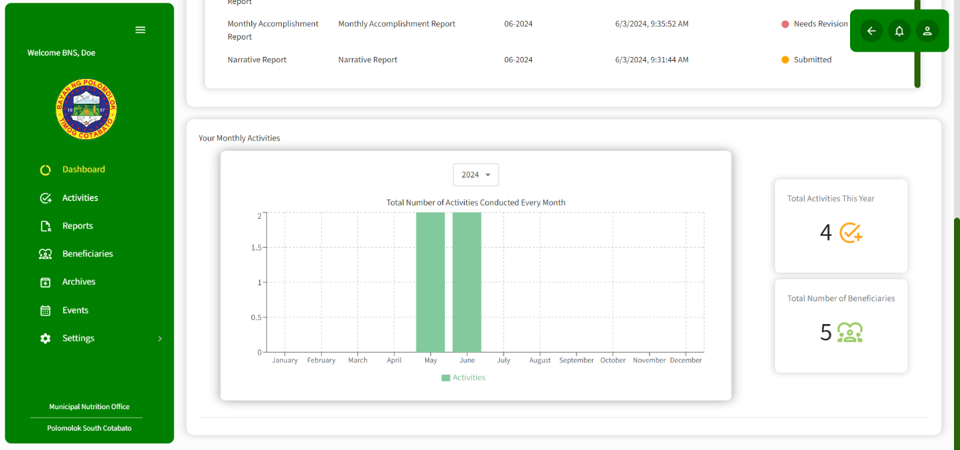DASHBOARD BNS ACTIVITY

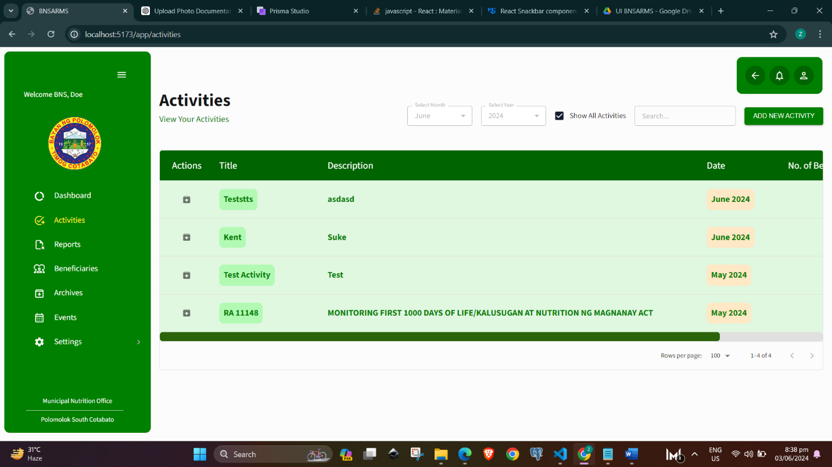BNS ACTIVITIES PAGE

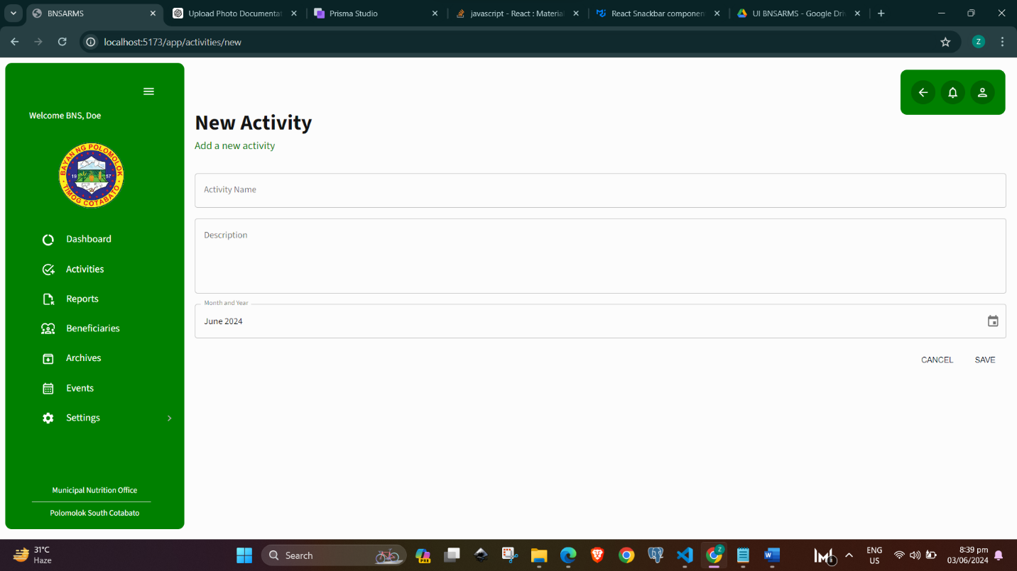BNS NEW ACTIVITIES PAGE

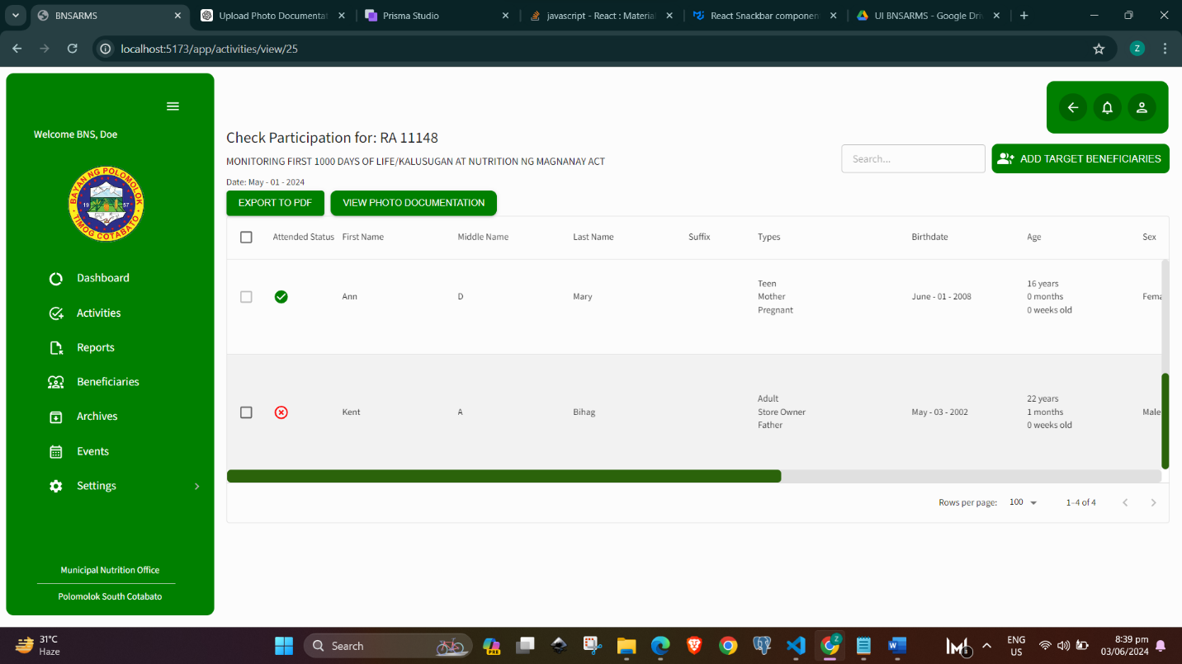BNS ACTIVITY PARTICIPATION PAGE

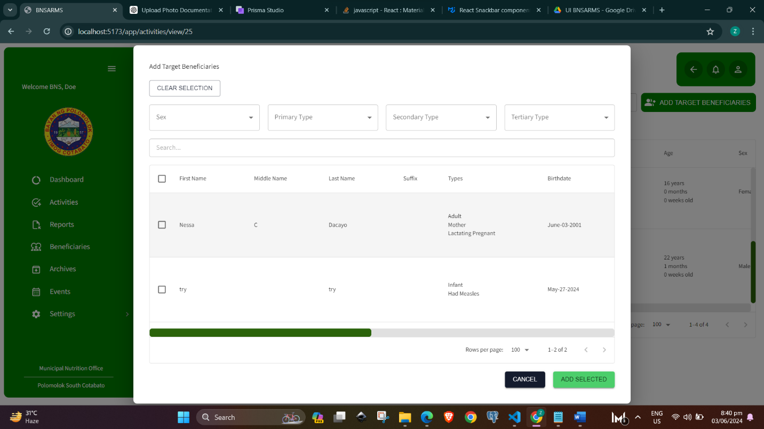ADD TARGET BENEFICIARIES PAGE

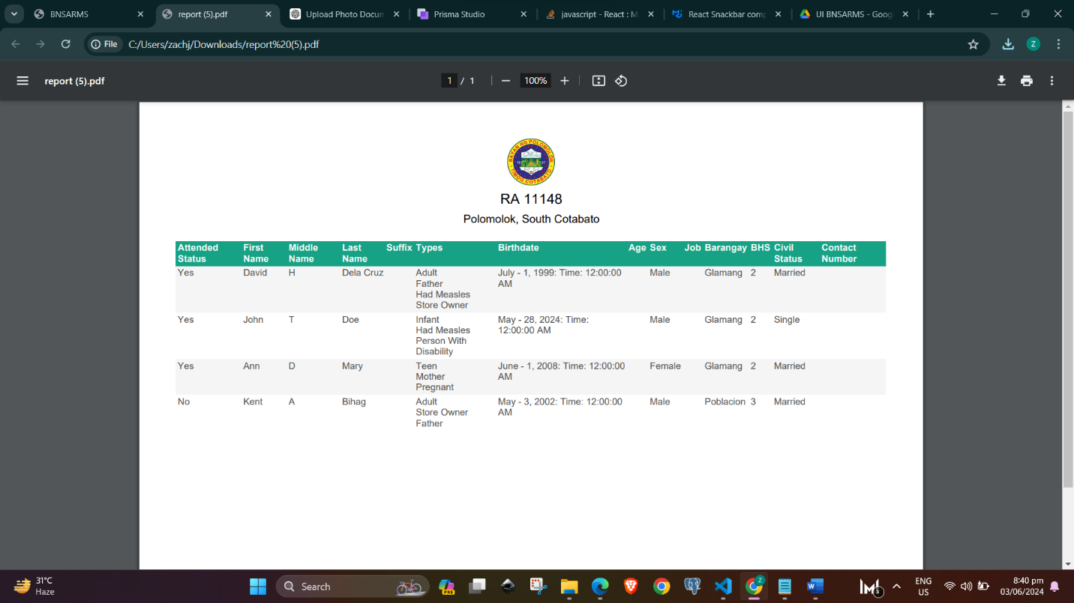PDF - EXPORTED ACTIVITY

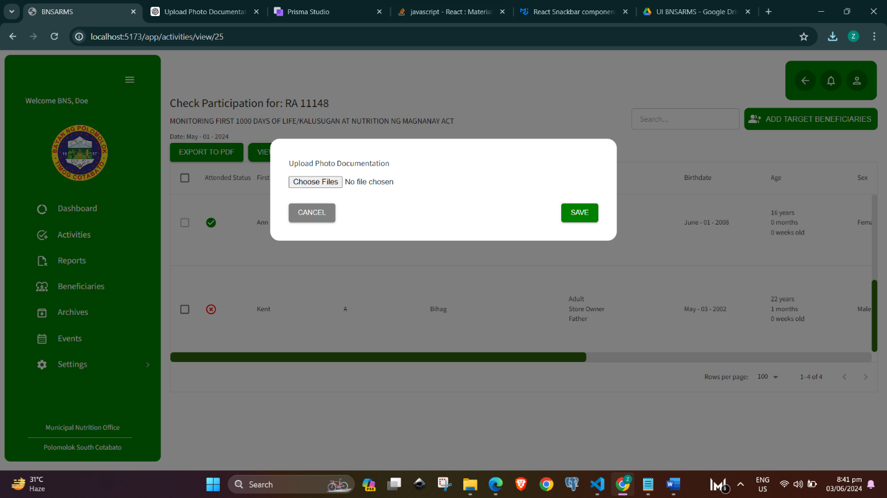ACTIVITY PHOTO DOCUMENTATION

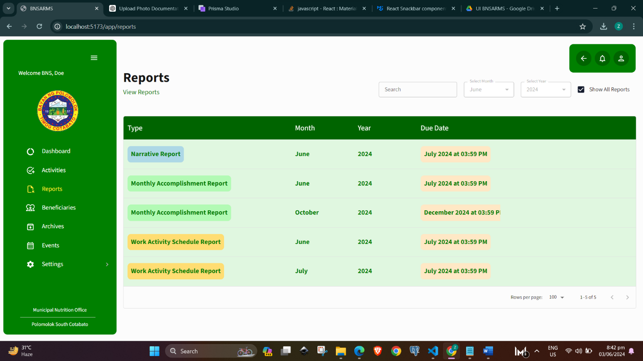BNS REPORTS

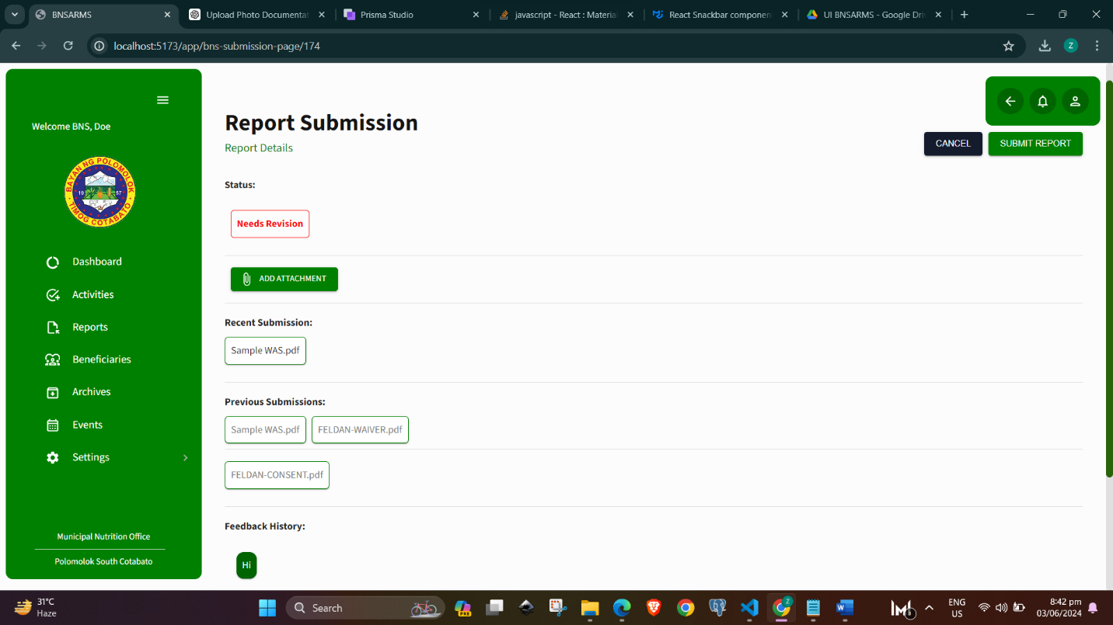BNS REPORT DETAILS

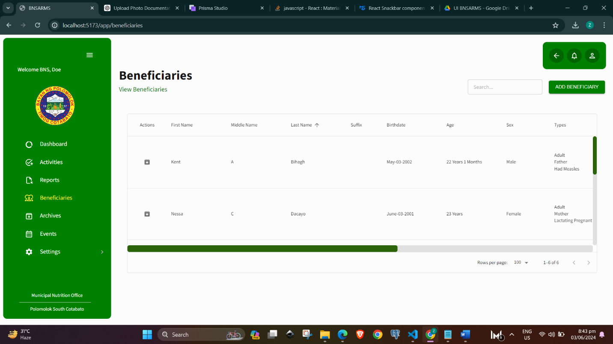BENEFICIARIES PAGE

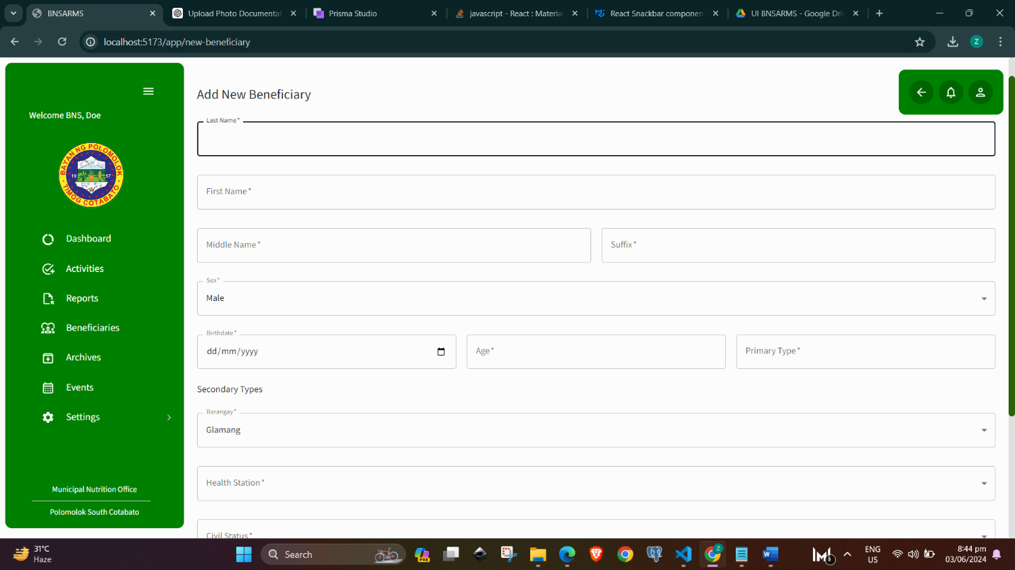ADD NEW BENEFICIARY PAGE

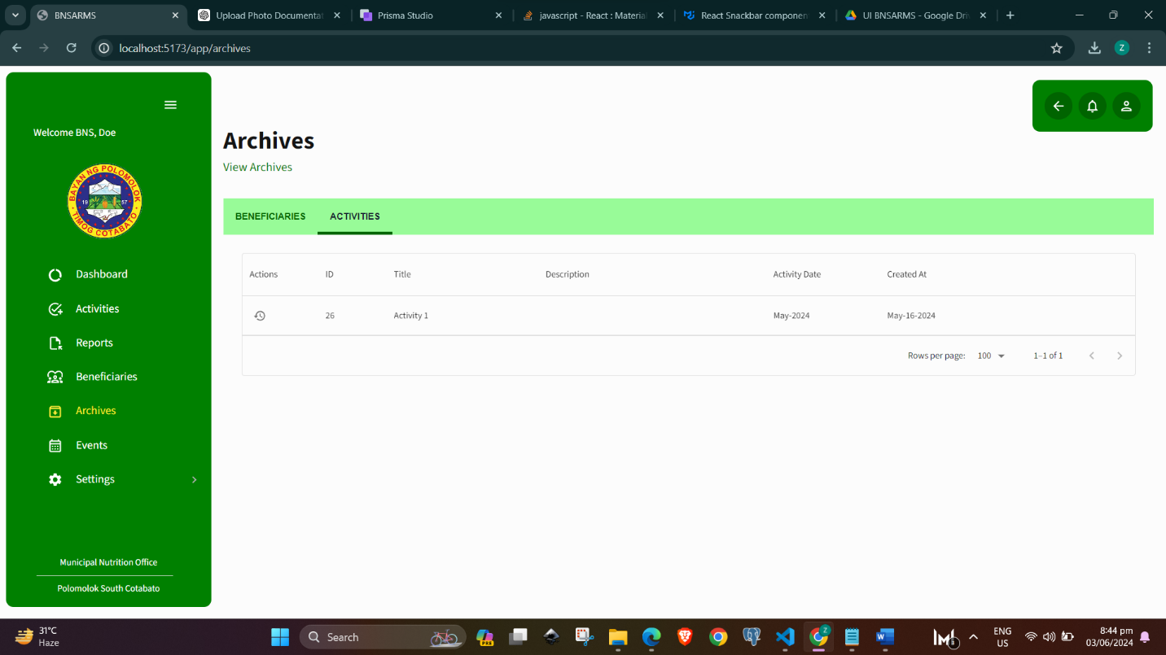**BNS ARCHIVES PAGE**

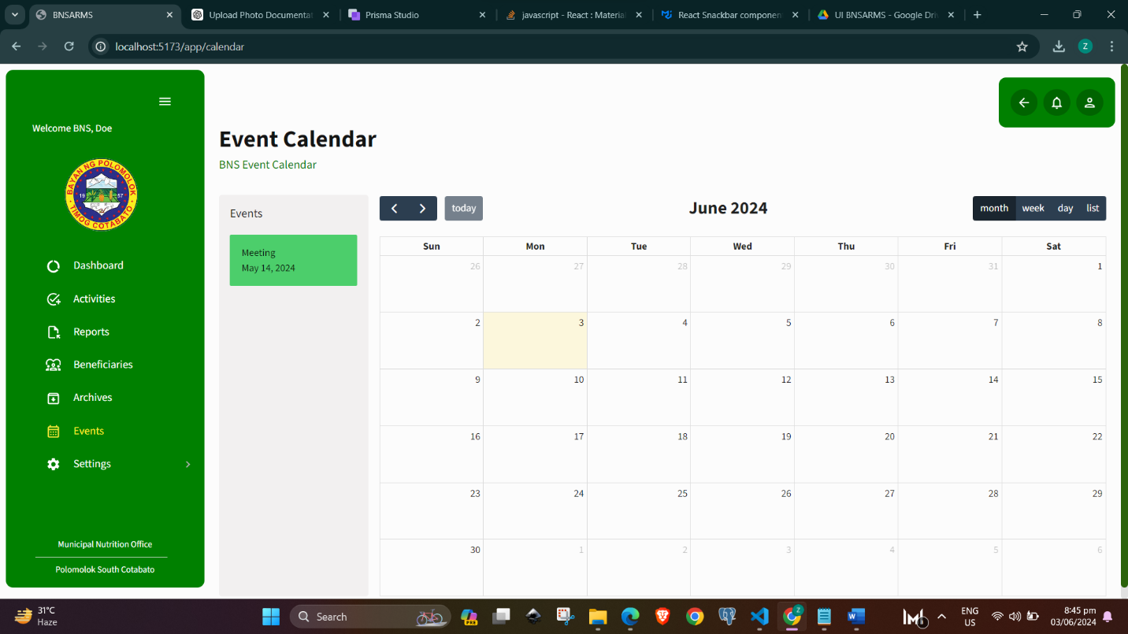**BNS EVENTS CALENDAR**

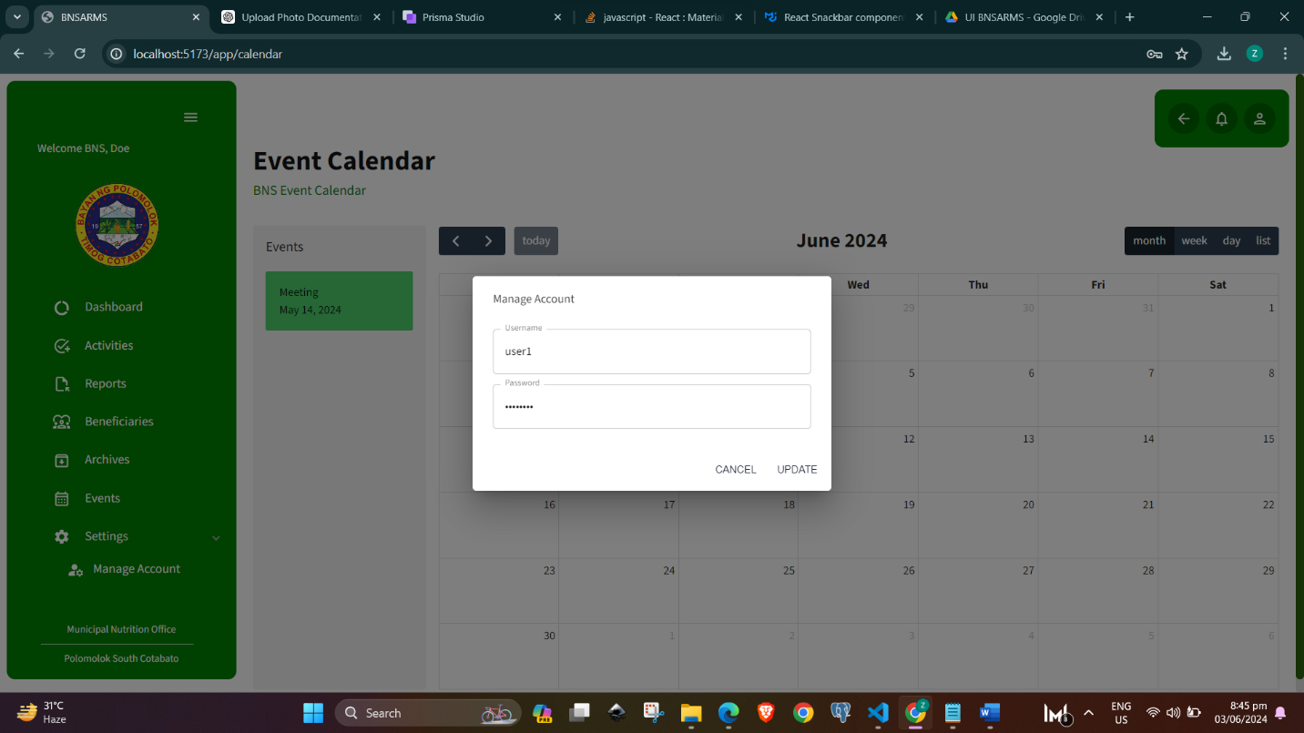**MANAFE ACCOUNT PAGE**

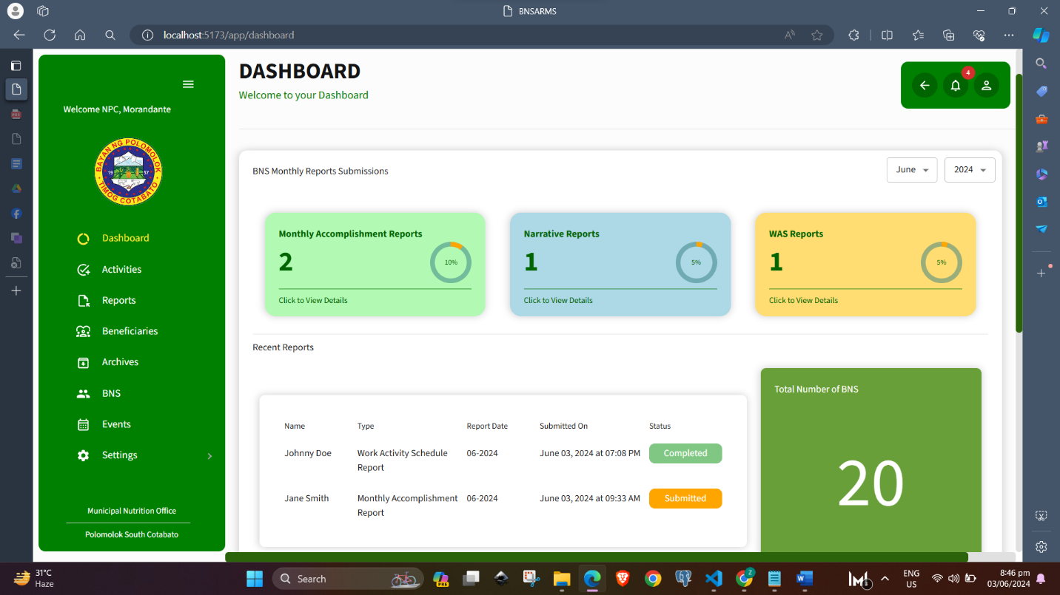**NPC DASHBOARD REPORT**

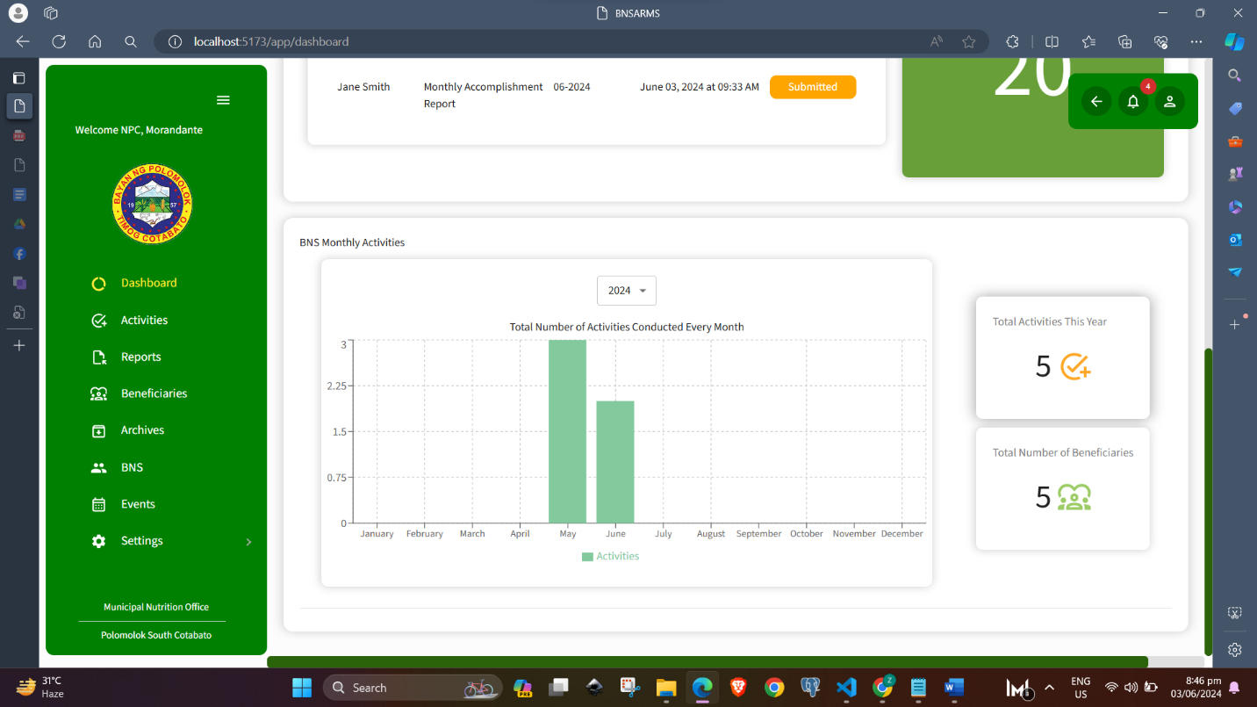**NPC DASHBOARD ACTIVITY**

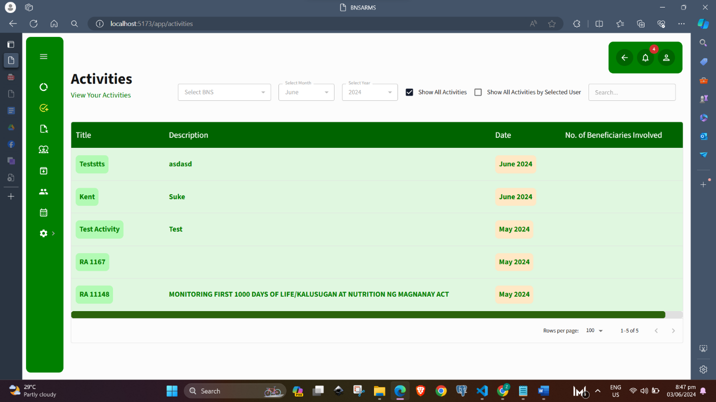

**ACTIVITIES PAGE – NPC SIDE**

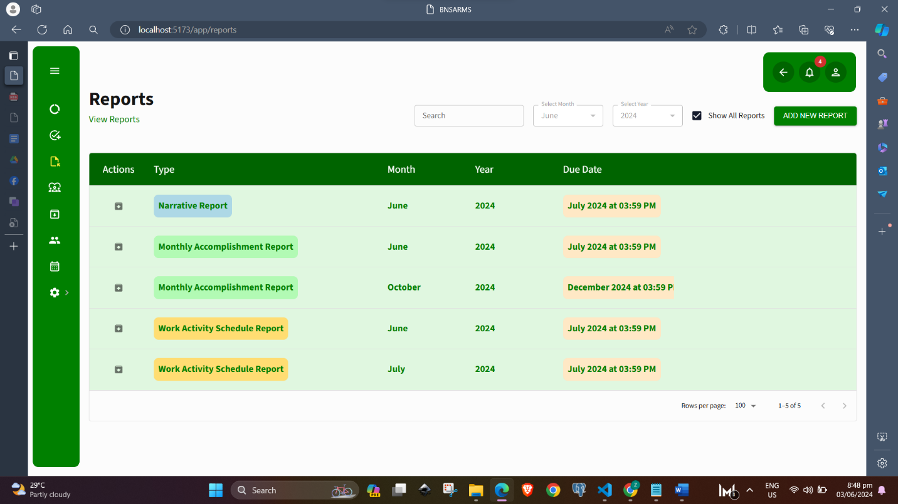**REPORTS NPC SIDE**

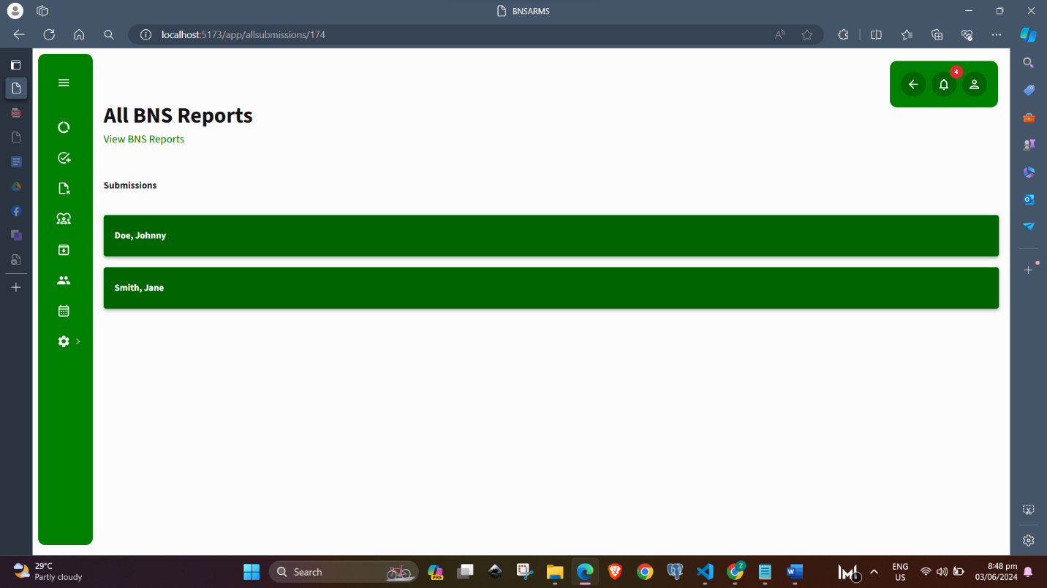**ALL BNS SUBMISSIONS LIST**

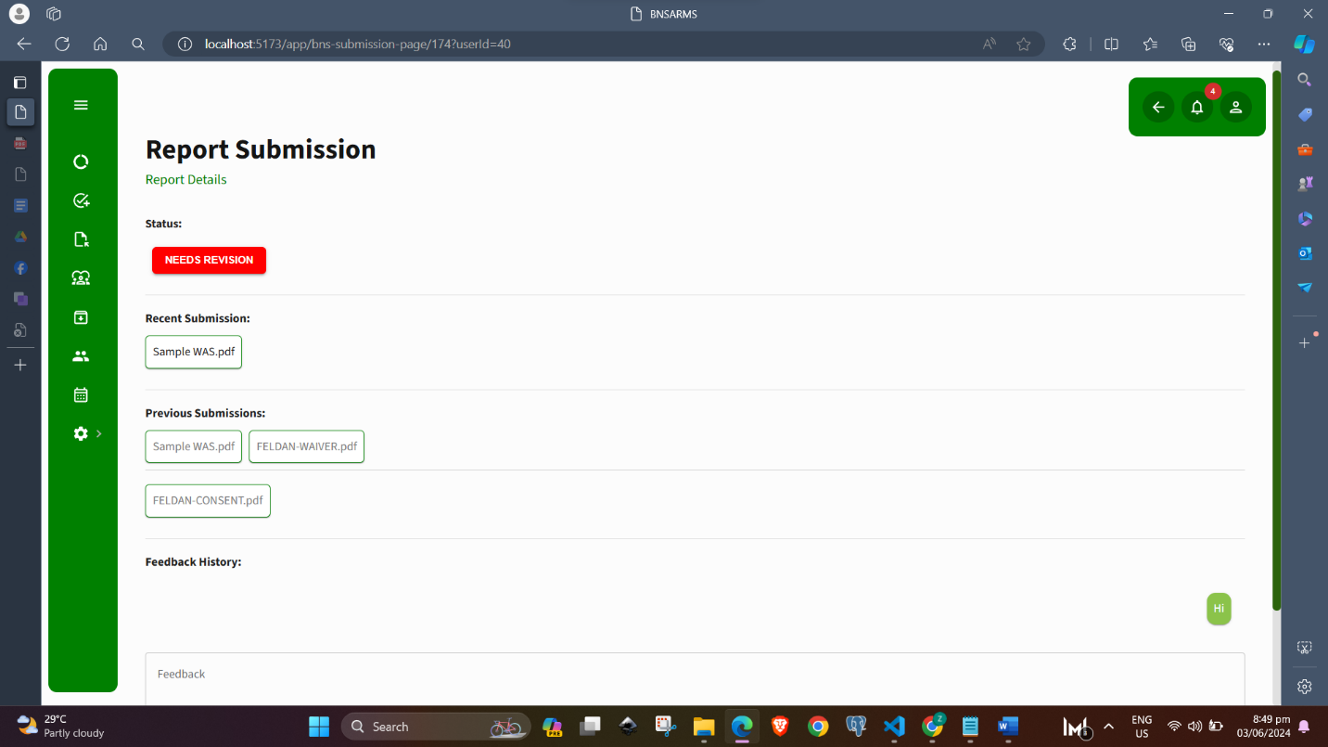**REPORT SUBMISSION DETAILS PAGE NPC SIDE**

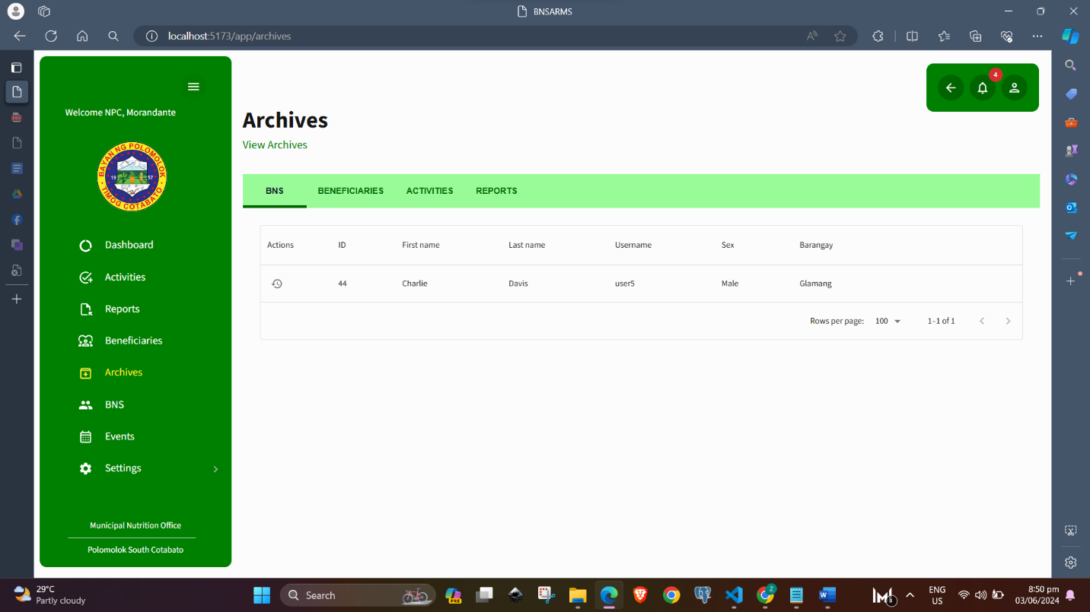**ARCHIVES NPC SIDE**

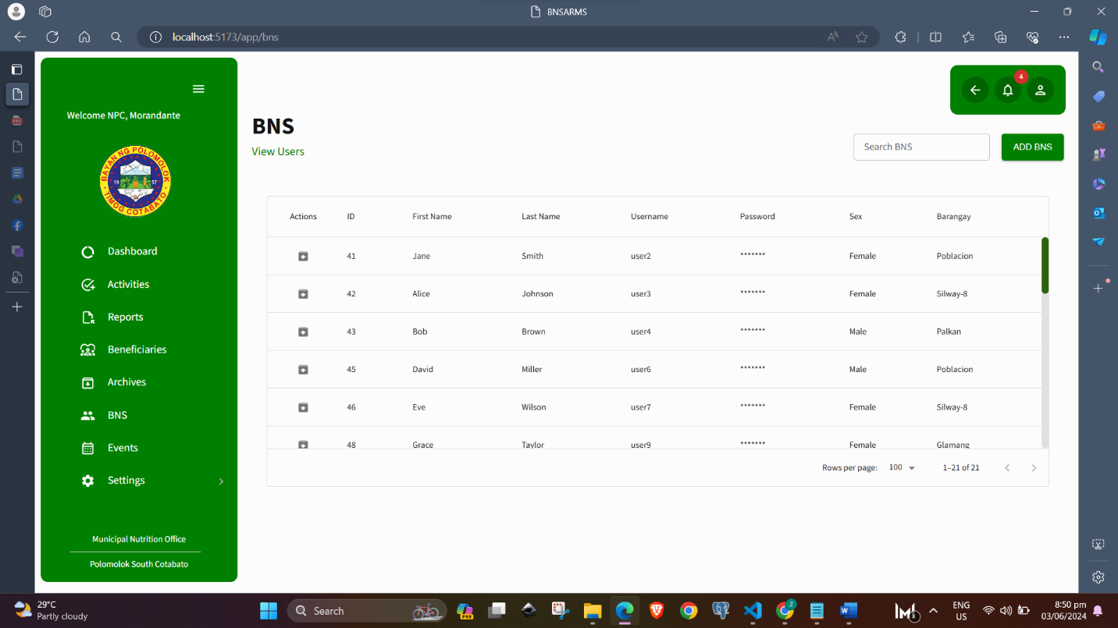MANAGE BNS PAGE

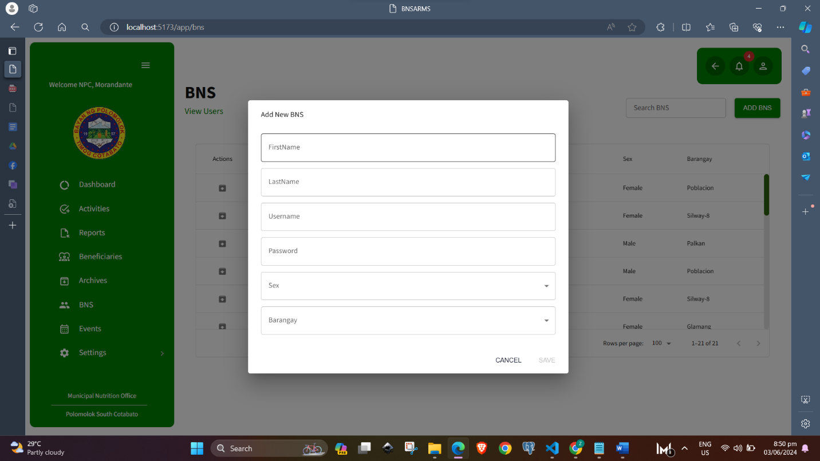CREATE NEW BNS PAGE

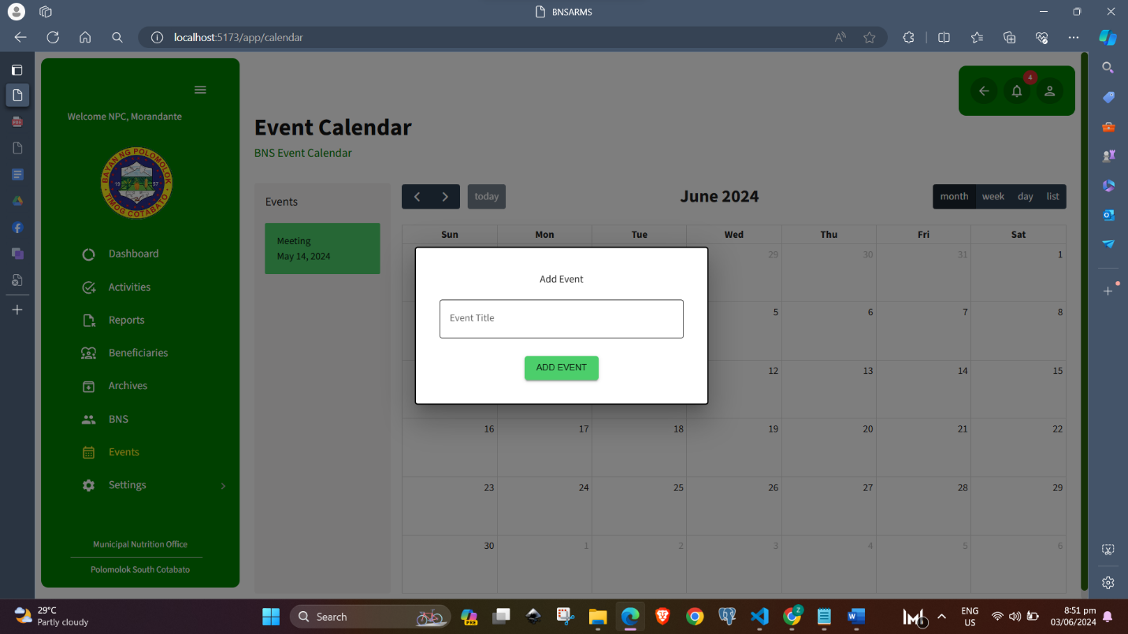CREATE NEW EVENTS PAGE

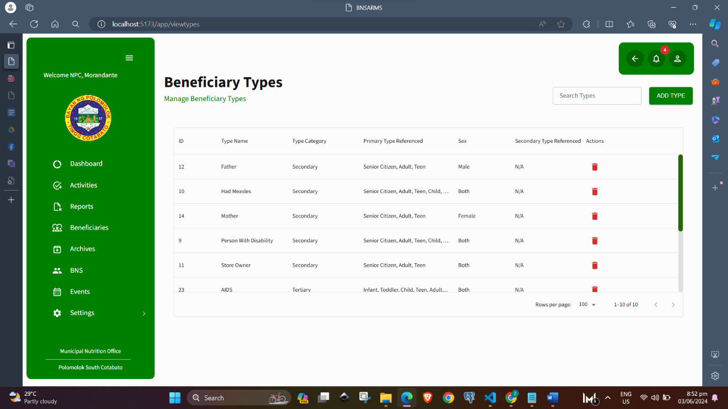BENEFICIARY TYPES PAGE

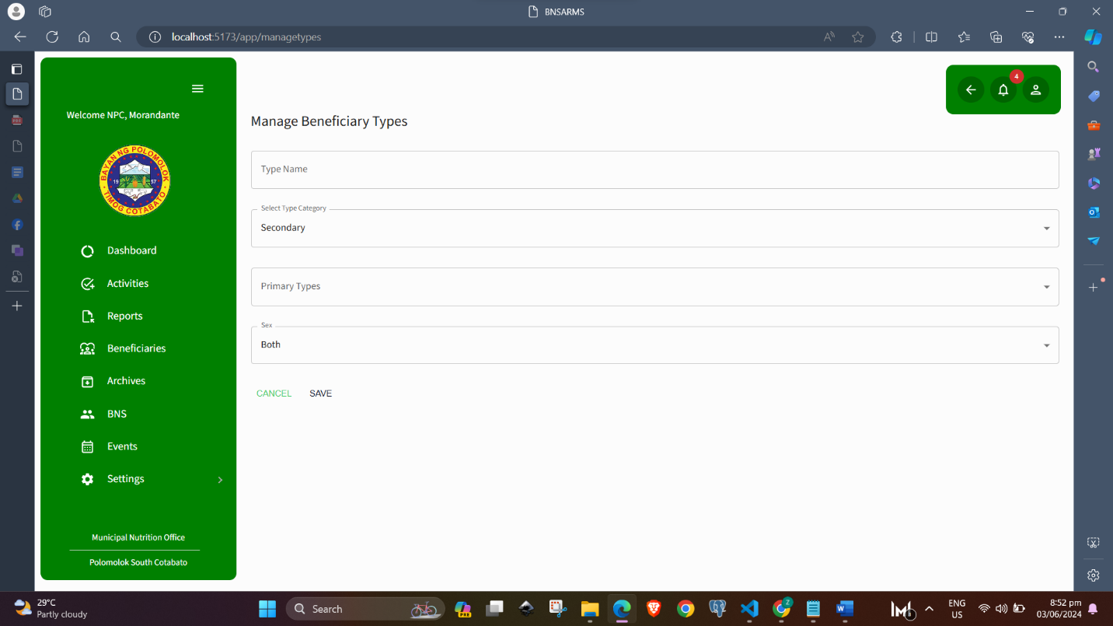CREATE NEW BENEFECIARY TYPE PAGE

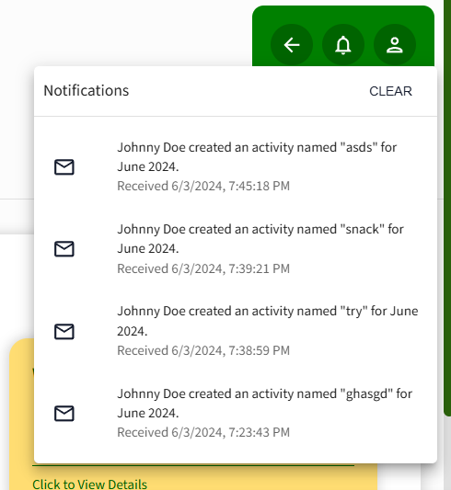NOTIFICATIONS

NOTE: BOTH BNS AND NPC CAN ADD/EDIT BENEFICIARY.